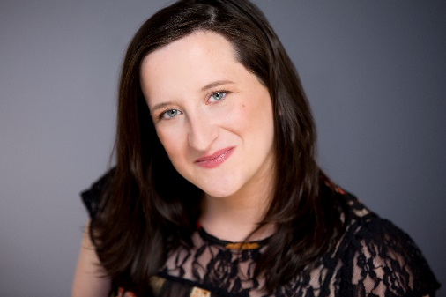
Danielle Krivinchuk
218-260-9047 Height: 5'2”
Danielle.m.kk@gmail.com Hair: Dark Brown Eyes: Blue

THEATRE (Representative Roles)
Titus Andronicus | Multiple | Royal Conservatoire of Scotland
Silent Sky | Annie Cannon | Lyric Arts
Arcadia | Jellaby | Chameleon Theatre Circle
The Oresteia | Athena | Hero Now Theatre Company
The Funny | Dani | Raw Sugar Theatre Company
Young Playwrights Festival | Margaret | Eugene O'Neil Theatre Center
The How and The Why | Rachel (Understudy) | Theatre Unbound
Eastern Standard | Ellen | Workhouse Theatre Company
Seven | Mukhtar | Chain Reaction Theatre
Synchronicity | Olive | Raw Sugar
Our Country's Good | Duckling | Starting Gate Theatre Company
Workshop | Rachel | Aethem Theatre Company
English Made Simple | Jill | Kismet Kreative Productions
Betty's Summer Vacation | Voice #2 | Chameleon Theatre Circle
Ministry of Ideas | Roxy | Schmidt Ellie Says
Much ado about Nothing | Ursula/Antonio | Six Elements Theatre Company
Before You Speak | Sheriff Collins | Freshwater Theatre Company
Captain Do Good Saves the Future Emma |  | Comedy Comics
Anon Mary |  | 20% Theatre Company
FILM
Speak UP (short) Lead Sheila Regan/Disquieted films
Meet Cute (Short) Lead Kyle Haack/Seat of Our Pants Productions

TRAINING
Classical Text Intensive Study- Shakespeare’s Globe, London
Actors Workout- Raye Birk, Guthrie Theatre
Voice Work -Yvonne Morley
Unarmed Stage Combat- BASSC Certified
Movement -Gabriella Moleta
National theatre Institute, Eugene O'Neil Theatre Center (CT)
B.A. Theatre Arts and Psychology, Hamline University
Master’s Classical and Contemporary Text, Royal Conservatoire of Scotland -Currently Attaining

SPECIAL SKILLS
Crisis Actor, Dance (jazz, modern, polka), Drawing, MC, Accent Equipped, Can touch my tongue to my nose

